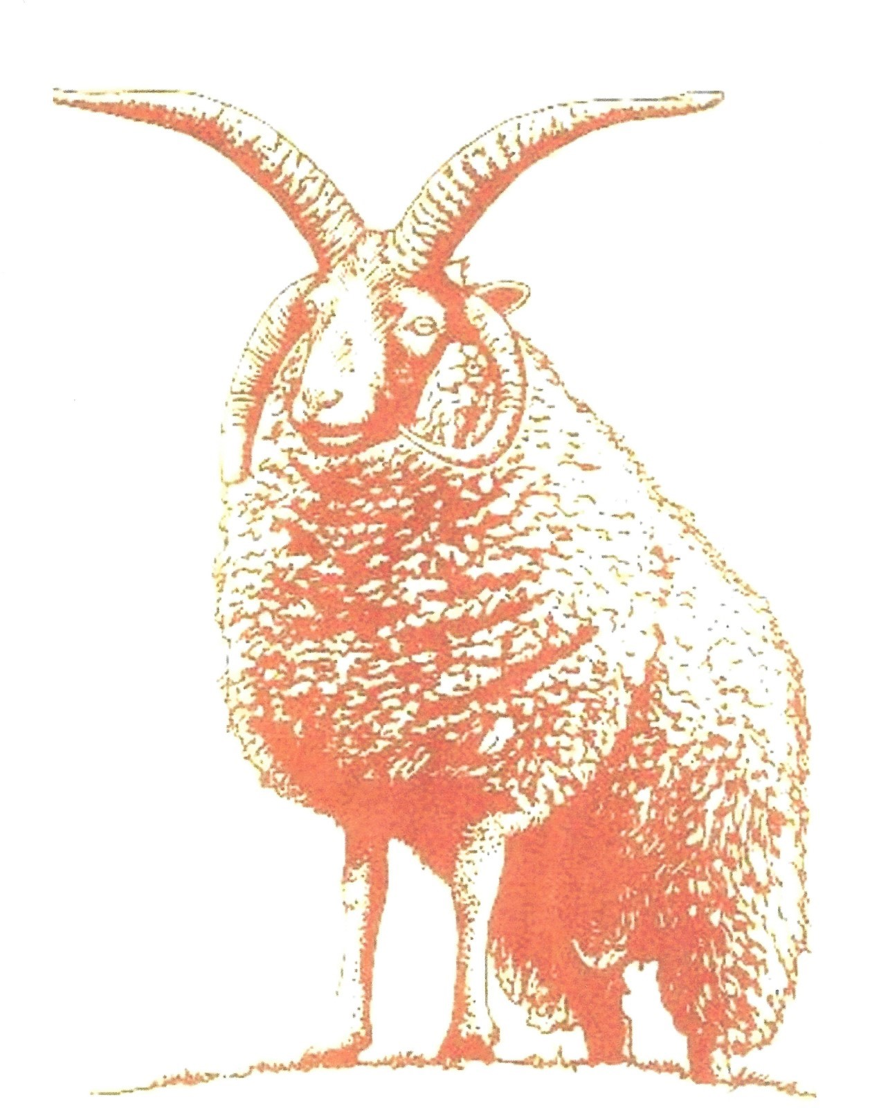
MEMBERSHIP APPLICATION FORM

I/we wish to join the

MANX LOAGHTAN SHEEP BREEDERS' GROUP

Individual Member £18 YES/NO

Family Member £25 YES/NO

I/we will pay by cash / cheque / on-line payment / standing order (delete as applicable):

Cheques to be payable to the Manx Loaghtan Sheep Breeders’ Group
Online Payment Sort Code 30-91-44 Account No 00512550
Standing Order payment date 1st July annually

PLEASE COMPLETE ALL OF THE FOLLOWING:

Name: |  |  |  |  |  | Date: |  | / /
Address:
Tel: | Home: |  | Work: |  | Mobile
E-mail:

Do you already own Manx Loaghtan Sheep? YES / NO
Number in flock: | Ewes: |  | Rams:

How long have you kept Manx Loaghtans?
Are you a member of the RBST?
Is your flock registered with RBST?
Is your main interest | Wool |  | Pedigree breeding |  |  | Cross breeding
 | Meat |  | Conservation |  |  | Other

Return the Form to The Secretary: | 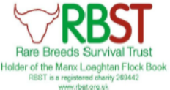
Carol Kempson
Cannons
Huntley Road
TIBBERTON
Gloucestershire
GL19 3AB
or email manxloaghtansheep@gmail.com

